MyData

Autogenerated data summary from dataMaid

2019-05-07 10:23:32

# Data report overview

The dataset examined has the following dimensions:

|  |  |
| --- | --- |
| Feature | Result |
| Number of observations | 205 |
| Number of variables | 10 |

### Checks performed

The following variable checks were performed, depending on the data type of each variable:

|  |  |  |  |  |  |  |  |  |
| --- | --- | --- | --- | --- | --- | --- | --- | --- |
|  | character | factor | labelled | haven labelled | numeric | integer | logical | Date |
| Identify miscoded missing values | × | × | × | × | × | × |  | × |
| Identify prefixed and suffixed whitespace | × | × | × | × |  |  |  |  |
| Identify levels with < 6 obs. | × | × | × | × |  |  |  |  |
| Identify case issues | × | × | × | × |  |  |  |  |
| Identify misclassified numeric or integer variables | × | × | × | × |  |  |  |  |
| Identify outliers |  |  |  |  | × | × |  | × |

Please note that all numerical values in the following have been rounded to 2 decimals.

# Summary table

|  |  |  |  |  |
| --- | --- | --- | --- | --- |
|  | Variable class | # unique values | Missing observations | Any problems? |
| X | integer | 205 | 0.00 % |  |
| time | integer | 194 | 0.00 % | × |
| status | integer | 3 | 0.00 % |  |
| sex | integer | 2 | 0.00 % |  |
| age | integer | 70 | 0.00 % | × |
| year | integer | 13 | 0.00 % |  |
| thickness | numeric | 64 | 0.00 % | × |
| ulcer | integer | 2 | 0.00 % |  |
| exit.date | factor | 205 | 0.00 % | × |
| site | factor | 5 | 0.00 % |  |

# Variable list

## X

|  |  |
| --- | --- |
| Feature | Result |
| Variable type | integer |
| Number of missing obs. | 0 (0 %) |
| Number of unique values | 205 |
| Median | 103 |
| 1st and 3rd quartiles | 52; 154 |
| Min. and max. | 1; 205 |

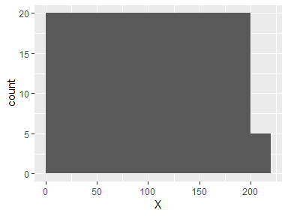

## time

|  |  |
| --- | --- |
| Feature | Result |
| Variable type | integer |
| Number of missing obs. | 0 (0 %) |
| Number of unique values | 194 |
| Median | 2005 |
| 1st and 3rd quartiles | 1525; 3042 |
| Min. and max. | 10; 5565 |

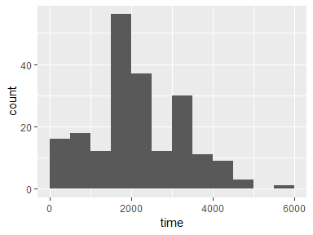

* Note that the following possible outlier values were detected: "10", "30", "35", "99", "185", "204", "210", "232", "279", "295".

## status

* Note that this variable is treated as a factor variable below, as it only takes a few unique values.

|  |  |
| --- | --- |
| Feature | Result |
| Variable type | integer |
| Number of missing obs. | 0 (0 %) |
| Number of unique values | 3 |
| Mode | “2” |
| Reference category | 1 |

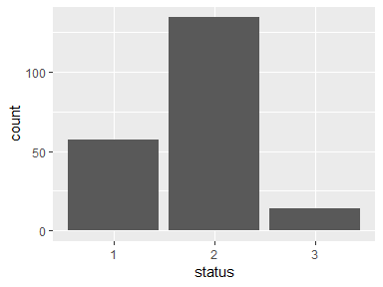

## sex

* Note that this variable is treated as a factor variable below, as it only takes a few unique values.

|  |  |
| --- | --- |
| Feature | Result |
| Variable type | integer |
| Number of missing obs. | 0 (0 %) |
| Number of unique values | 2 |
| Mode | “0” |
| Reference category | 0 |

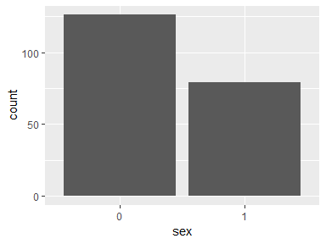

## age

|  |  |
| --- | --- |
| Feature | Result |
| Variable type | integer |
| Number of missing obs. | 0 (0 %) |
| Number of unique values | 70 |
| Median | 54 |
| 1st and 3rd quartiles | 42; 65 |
| Min. and max. | 4; 95 |

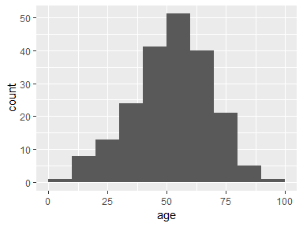

* Note that the following possible outlier values were detected: "86", "89", "95".

## year

|  |  |
| --- | --- |
| Feature | Result |
| Variable type | integer |
| Number of missing obs. | 0 (0 %) |
| Number of unique values | 13 |
| Median | 1970 |
| 1st and 3rd quartiles | 1968; 1972 |
| Min. and max. | 1962; 1977 |

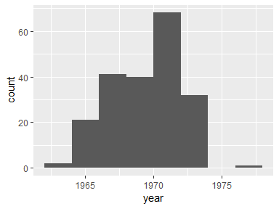

## thickness

|  |  |
| --- | --- |
| Feature | Result |
| Variable type | numeric |
| Number of missing obs. | 0 (0 %) |
| Number of unique values | 64 |
| Median | 1.94 |
| 1st and 3rd quartiles | 0.97; 3.56 |
| Min. and max. | 0.1; 17.42 |

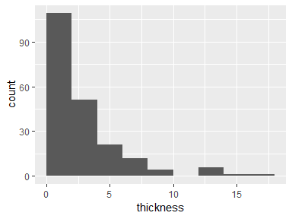

* Note that the following possible outlier values were detected: "0.1", "17.42".

## ulcer

* Note that this variable is treated as a factor variable below, as it only takes a few unique values.

|  |  |
| --- | --- |
| Feature | Result |
| Variable type | integer |
| Number of missing obs. | 0 (0 %) |
| Number of unique values | 2 |
| Mode | “0” |
| Reference category | 0 |

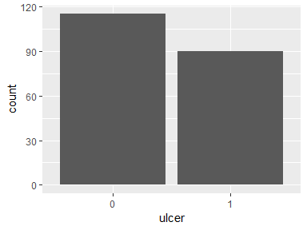

## exit.date

* The variable is a key (distinct values for each observation).

## site

|  |  |
| --- | --- |
| Feature | Result |
| Variable type | factor |
| Number of missing obs. | 0 (0 %) |
| Number of unique values | 5 |
| Mode | “Ã…mol” |
| Reference category | MÃ¼nchen |

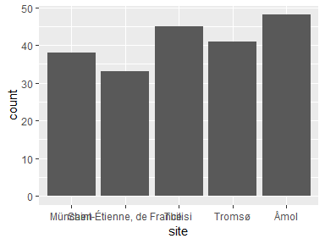

Report generation information:

* Created by Tingting (username: tingtinf).
* Report creation time: tir. mai 07 2019 10:23:32
* Report was run from directory: C:/Users/tingtinf/Documents
* dataMaid v1.2.0 [Pkg: 2018-10-03 from CRAN (R 3.6.0)]
* R version 3.6.0 (2019-04-26).
* Platform: x86_64-w64-mingw32/x64 (64-bit)(Windows 10 x64 (build 17134)).
* Function call: makeDataReport(data = MyData)